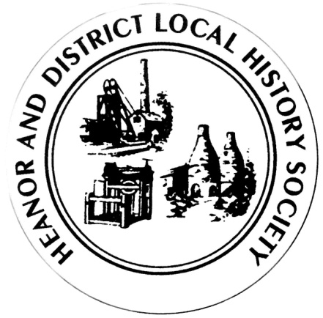We want your memories! As part of an ongoing project, the Heanor & District Local History Society wants to hear from YOU.
We would like to establish a collection of people’s memories about the area - it can be from any period, and from any part of the district. And ANY subject - whether home life, work life, shopping, leisure. It doesn’t matter how trivial you may think your reminiscences are, they will help form part of a much bigger picture, which we can use to assist our future research, publications and newsletters.
This is nothing new of course; we have always asked for this from our members, but have now decided to use this method to try to prompt people to give information on specific issues.
This month’s topic is: Clubs and Societies.
What we’re looking at here are things (other than sports and activities connected with public houses) which you may have done in the past, and which were organised groups. Examples would include: dancing schools, choirs, music lessons, dog shows, Rotary Club, literary clubs, Women’s Institutes, amateur dramatics, model railway clubs, adult education classes – in fact the list is pretty endless!

How to pass the information onto us:
- If you normally attend our meetings, just fill in the form and hand it back at the next meeting.
- If you don’t attend our meetings, then you can send us an email with the information (mail@heanorhistory.org.uk).
We would rather that you didn’t send us information anonymously, but nobody’s name will be published unless you have specifically given us permission to do so. In particular, we WILL NOT publish anything which of a personal or potentially sensitive nature.
Name | Address
Telephone
Email address
Are you willing for your name to be linked to any information supplied? |  | Yes / No
Would you be prepared to discuss this or related information further? |  | Yes / No

P.T.O.

In this questionnaire, we want you to think about any clubs or societies you were a member of, or any other organised social activities you took part in in the past. However, we would prefer you not to talk about sporting activities or activities relating to public houses, both of which will feature in future questionnaires. Concentrate on just one activity per sheet.
How old were you, and, roughly, what year was it?
What was the name of the club/society – where did you meet?

Did you have to pay to take part? How much?
What was involved? How often did you meet? Were there competitions/exams?
Who was the leader of the group/classes? Can you remember others who attended?
Tell us of any especially memorable event/incident.

Why did you end this activity?
Please use a separate sheet if necessary.
Thank you

